
PB-T2/GEAK/1221/A 17-MAR-2022
PRE BOARD EXAMINATION – TERM II (2021-22)
Subject: GEOGRAPHY  Grade: XII |  | Max. Marks: 35  Time: 1hr 10 Minutes
SECTION A
(VSA)
1. | Write the meaning of ‘Digital Divide’  There are wide ranging economic, political and social differences among countries. How quickly countries can provide ICT access and benefits to its citizens is the deciding factor. While developed countries in general have surged forward, the developing countries have lagged behind and this is known as the digital divide. |  | 2
2. | What is ‘Trans- Continental Railway’. Give an example  Trans–continental railways run across the continent and link its two ends. They were constructed for economic and political reasons to facilitate long runs in different directions. Example: Trans-Siberian Railways. |  | 2
3. | Bring about any one major comparison between ‘Urban and Rural marketing centers’ an example each |  | 2
  Rural Marketing Centres | Urban Marketing Centres
  Rural marketing centre provide facility to nearby settlements. | Urban marketing centre provide facility to wide services to large areas.
  Rural centres are mostly rudimentary type. | Urban centres offer specialised services.
  Personal and professional services are undeveloped in rural centres. | They are highly developed in urban centres.
  Rural marketing centres acts as a local collecting and distributing centres. | Urban marketing centres provide services beyond cities at national or international levels.
 | OR
What is the nature of work against the following colour :
(i) Gold -highly skilled profession
(ii) Blue -Manual labours
SECTION B
SOURCE BASED QUESTION
4 | Read the case study given below and answer the questions that follow:  The challenge of sustainable development requires integration of quest for economic development with environmental concerns .Traditional methods of resource use result into generating enormous quantity of waste as well as create other environmental problems. Hence, sustainable development calls for the protection of resources for the future generations. There is an urgent need to conserve the resources. The alternative energy sources like solar power, wind, wave , geothermal energy are inexhaustible resource .These should be developed to replace the exhaustible resources. In case of metallic minerals, use of scrap metals will enable recycling of metals. Use of scrap is specially significant in metals like copper, lead and zinc in which India’s reserves are meagre. Use of substitutes for scarce metals may also reduce their consumption. Export of strategic and scarce minerals must be reduced, so that the existing reserve may be used for a longer period.2019-20
4.1 | What is sustainable development ?  Ans :- Sustainable development is an organizing principle for meeting human development goals while also sustaining the ability of natural systems to provide the natural resources and ecosystem services on which the economy and society depend |  | 1
4.2 | Write any two measures to conserve resources.  Ans :- a. Search of alternative resources (eg - non-conventional source of energy )  b. Use of scrap metals  c. Recycling of metals |  | 1
4.3 | Why conventional sources of energy must be conserved ?  Ans :- As conventional sources of energy are exhaustible and their stock is limited . |  | 1
SECTION C
SHORT ANSWERS
5. | Elucidate the statement- ‘Satellite and communication brought about revolutionary changes in the field of communication’.  *Satellites touch human lives in many ways. Every time we use a cell phone to call a friend, send an SMS or watch a popular programme on cable television, we are using satellite communication.  *These have rendered the unit cost and time of communication invariant in terms of distance.  *Today weather forecasting through television is a boon in saving the loss of life and property.  *As billions use the Internet each year, cyberspace will expand the contemporary economic and social space of humans through email, e-commerce, e-learning and e-governance.  * It is these modern communication systems, more than transportation that has made the concept of global village |  | 3
6. | Identify the given below water way.  Rhine water way |  | 1+2
How has this water way been a boon for those countries through which it passes?
i)The Rhine flows through Germany and the Netherlands.
ii)The Ruhr river joins the Rhine from the east. It flows through a rich coalfield and the whole basin has become a prosperous manufacturing area.
iii) It connects the industrial areas of Switzerland, Germany, France, Belgium and the Netherlands with the North Atlantic Sea Route.
 | 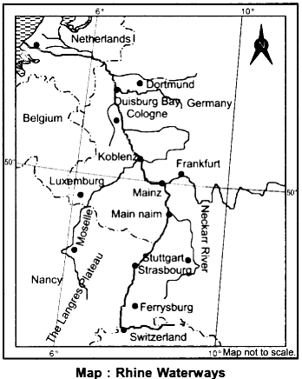
 | OR
'Africa has immense natural resources and yet it is industrially the most backward continent'. Comment.
Ans • Unfavorable Climatic conditions. • Low level of technological development • Lack of Rapid network of transport & communication • Lack of developed Energy Resources. • Lack of market facilities.
SECTION D
LONG ANSWERS
7 | How do Quaternary services differ from Tertiary services? Give three reasons why the service sector in developing and developed countries is growing faster than the manufacturing sector?  I)The activities which involve intangible outputs and are relatively attached from material production such as the services of a technician or a teacher are referred to as Tertiary activities. (ii)The activities concerning knowledge such as education, information, research and development and more intellectual activities where the major task is to think, research and develop ideas are quaternary activities. (iii)The rising per capita income in both, developed and developing countries has generated proportionately larger increases in the many kinds of services. (iv)There is also demand for educational services at all levels with the increase in the demand for literacy and computer skills at the workplace. (v) for non-direct production workers is also increasing proportionally in most manufacturing companies as these companies need more clerical staff, sales people, research and other workers.(vi) Medical services have also increased in Europe, North America and Japan because of an increase in demand for medical care from the elderly population. |  | 2+3
8 | How is the use of plastic bags harmful for environmental degradation? Evaluate it by citing suitable reasons.  ● Chemicals added to plastics are absorbed by human bodies. Some of these compounds have been found to alter hormones or have other potential human health effects. ● Plastic debris, laced with chemicals and often ingested by marine animals, can injure or poison wildlife. ● Floating plastic waste, which can survive for thousands of years in water, serves as mini transportation devices for invasive species, disrupting habitats. ● Plastic buried deep in landfills can leach harmful chemicals that spread into groundwater. ● Around 4 percent of world oil production is used as a feedstock to make plastics, and a similar amount is consumed as energy in the process |  | 5
 | OR
The disposal of urban waste has become a serious concern for the local authorities. Analyze the statement with suitable examples.
The problem of overcrowded, congested and insufficient infrastructure of urban areas results in accumulation of huge urban waste. There are two sources of urban waste. Household or domestic sources and industrial or commercial sources. The mismanagement of urban waste disposal is a serious problem in big cities.
Tons of waste come out daily in metropolitan cities and are burnt. The smoke released from the waste pollutes the air. Lack of sewers or other means to dispose of human excretes safely and the inadequacy of garbage collection sources adds to water pollution. The concentration of industrial units in and around urban centres gives rise to a series of environmental problems.
Dumping of industrial waste into rivers is the major cause of water pollution. The solid waste generation continues to increase in both absolute and per capita in cities. This improper disposal of solid waste attracts rodents and flies which spread diseases. The thermal plants release a lot of smoke and ash in the air. For example, a plant producing 500mw electricity releases 2000 tons of ash which is difficult to manage.
9 | . Attaining Sustainable development in the command area requires major thrust upon the measures to achieve ecological sustainability. Highlight the measures proposed to promote sustainable development in the command area of Indira Gandhi Rajasthan Canal.  (i) The first requirement is strict implementation of water management policy. The canal project envisages protective irrigation in Stage-I and extensive irrigation of crops and pasture development in Stage-II. (ii) In general, the cropping pattern shall not include water intensive crops. It shall be adhered to and people shall be encouraged to grow plantation crops such as citrus fruits. (iii) The CAD programmes such as lining of water courses, land development and leveling and warabandi system (equal distribution of canal water in the command area of outlet) shall be effectively implemented to reduce the conveyance loss of water. (iv) The areas affected by water logging and soil salinity shall be reclaimed. (v) The eco-development through afforestation, shelterbelt plantation and pasture development is necessary particularly in the fragile environment of Stage-II. |  | 5
 | SECTION E  MAP QUESTIONS |  | 5
10.1 | Identify the following on the political map of the world.  A. A major airport - Tokyo  B. A major sea port. - Durban  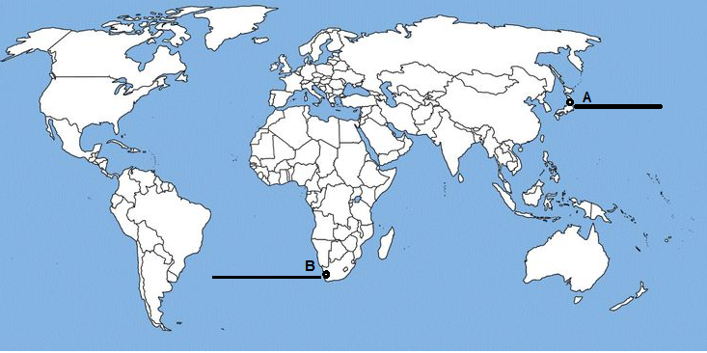
10.2 | On the outline map of India indicate and mark the following features (Attempt any 3). 1x5=5  - Iron ore mines in Karnataka ( Ballari)  - Manganese mine - Balaghat  - Coal mine in Tamil nadu (Neyveli)  - Oil field in Uttar Pradesh ( Mathura)
